Table of Contents

[1. Introduction 5](#_Toc21605340)

[2. Literature Review 7](#_Toc21605341)

[2.1 IT in food industry 7](#_Toc21605342)

[2.2 Blockchain in market places 7](#_Toc21605343)

[2.3 Existing Solutions 8](#_Toc21605344)

[2.4 Differences of the existing solutions 8](#_Toc21605345)

[2.5 Rich Picture Diagram 9](#_Toc21605346)

[3 Problem and Motivation 10](#_Toc21605347)

[3.1 Problem 10](#_Toc21605348)

[3.1.1 Background 10](#_Toc21605349)

[3.1.2 General Problem 11](#_Toc21605350)

[3.1.3 Research Question 11](#_Toc21605351)

[3.2 Aim 11](#_Toc21605352)

[3.3 Motivation 11](#_Toc21605353)

[3.4 Objectives 12](#_Toc21605354)

[4. Required Resources 13](#_Toc21605355)

[4.1 Software Requirements 13](#_Toc21605356)

[4.2 Hardware Requirements 13](#_Toc21605357)

[5. Project Requirement 14](#_Toc21605358)

[5.1. Functional Requirements 14](#_Toc21605359)

[5.2 Non-Functional Requirements 14](#_Toc21605360)

[6. Timeline 15](#_Toc21605361)

[References 16](#_Toc21605362)

List of Figures

[Figure 1 : Toasttabs survey on most popular aggregate sites 4](file:////Users/rasheenruwisha/Desktop/Table%20of%20Contents.docx#_Toc21601823)

[Figure 2: Rich Picture Diagram 7](file:////Users/rasheenruwisha/Desktop/Table%20of%20Contents.docx#_Toc21601824)

[Figure 3 : ToastTabs survey on most used online ordering platform 8](#_Toc21601825)

[Figure 4 : Timeline diagram 12](file:////Users/rasheenruwisha/Desktop/Table%20of%20Contents.docx" \l "_Toc21601826)

List of Tables

[Table 1 : Software Requirement for Development 13](#_Toc21606040)

[Table 2: Hardware requirements from business 13](#_Toc21606041)

[Table 3: Laptop and Mobile hardware requirements for customer 13](#_Toc21606042)

List of Abbreviations

1. APK – Android Package Application
2. IOS – Internet Operating System

# 

# 1. Introduction

The restaurant industry is one of the rapidly growing industries across the globe, with many food chains opening up increasing the competition. As the target customer base of the restaurants changes rapidly they have to come up with solutions to attract the customers. The main solution for this problem have been to have their own website or an order-ahead app which have increased the restaurant sales as people prefer to order using the website or order ahead applications. Order ahead applications allow users to order ahead of time while allowing the users to dine as they arrive, or get the order delivered to the house while allowing pay on arrival and pay on order.

With the emergence of order ahead applications and other aggregate online ordering services clients tend to use the existing applications to order the food and make reservations to save time, which is convenient to the customer.

The restaurants with order ahead application have seen more success over time over the restaurants which do not equip any kind of order ahead procedures as people tend to use most of their time doing something which benefits them. Looking from the entrepreneur’s perspective this will allow them to increase their sales and have no fee to be payed to any Online Aggregate sites.

Online ordering using a restaurant website, order ahead applications, aggregate sites have been one of the increasing tends in the recent due to the ease and the speed of the delivery, order ahead application allow you to order ahead of time and get the food delivered to you if the restaurant supports delivery or make sure that the order is ready to be collected when you arrive at the restaurant.

Within the past year, guests ordered most on Grubhub (25%), UberEats (26%), Doordash (21%), and those three have been the most popular aggregate sites among the restaurateurs as well.(Toast Inc., 2018)

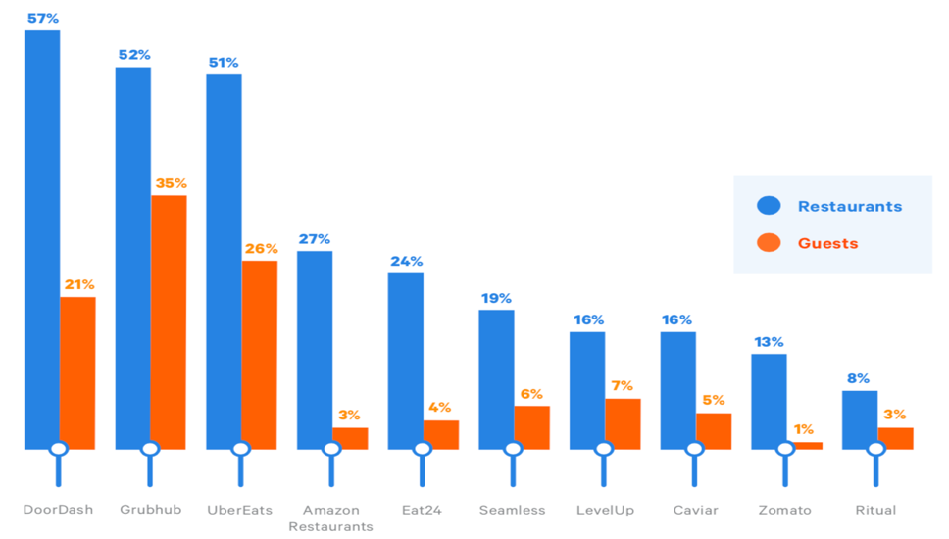

Figure 1 : Toasttabs survey on most popular aggregate sites

According to a ToastLabs survey done to collect the customer requirements for a restaurant, Guests listed Wi-Fi availability, online reservations, and consumer ordering programs as restaurant technologies most important to their guest experience.(Toast Inc., 2018)

“51% of guests ordered from a restaurant website in the past month, 31% of guests ordered using an Online Ordering Aggregate Site while 28% ordered using Restaurant Food Ordering System.”Another technology that stood out as important for both groups was online reservations: **51% of guests** marked it as extremely important, while **41% of restaurant professionals** marked it as extremely important.(Toast Inc., 2018)

Blockchain is an immutable distributed ledger that allows transactions to take place in a decentralized manner. The ledger is spread across the peers in the network while each of the peers hold a copy of the complete ledger. The data in the blockchain is stored in blocks creating a chain blocks which is linked together.

Blockchain which allows data decentralization based on various mechanisms is considered one of the leading technologies of the next generation. The growth of cryptocurrencies as Bitcoin blockchain is definitely one of the hottest topics of the year (Nakamoto, 2008). Blockchain has been one of the technologies that have been able to cause disruptive changes in many of the industries due to its openness and the integrity of the data that is stored in chains.

# 2. Literature Review

## 2.1 IT in food industry

With the evolution of technology people tend to adapt to the new technologies, with these advancements in technology businesses tend to adapt those technologies to meet customer requirements. With the introduction on online ordering and order ahead application the restaurant with online ordering has seen a reasonable success compared to other restaurants.

As many surveys and other data gathering proves, online ordering has been having a great impact on the business sales.

“45% of consumers say that offering an ordering solution that is mobile is a must. And loyalty programs would encourage them to utilize online ordering services more regularly”

(Applova, no date)

The technological advancement in the industries have changed causing the business model to grow and provide efficient systems that can help improve the productivity and profitability of a restaurant using online food delivery systems. The use of online food delivery system is believed that it can lead the restaurant’s business grow from time to time and will help the restaurants to facilitate major business online.(HONG, 2016). As a matter of fact, people tend to reduce time wastage of cooking and going to restaurants earlier, by ordering ahead of the time or getting the food delivered.

The online food ordering systems provides convenience for customers as it helps them overcome the traditional queuing system, allowing them to save time.(Magnani, Tilwani and Suvarna, 2017).This will also allow the business to be more productive and effective in the customer service perspective.

## 2.2 Blockchain in market places

“Statistics about the application were gathered on the Rinkeby test network. The application was shown to have an average transaction runtime of 3.8 seconds, and an average gas consumption of 4.6 wei. Contract creation times for the application were shown to be less than a second. A cost analysis of the application was then conducted. The gas consumption of the transactions needed to both buy and sell a product was converted into US dollars, and the gas cost of the application was then compared to the cost to use an online auction marketplace such as eBay as well as an in-person auction house such as Sotheby’s. The results showed that selling on the application is cheaper than existing online options as well as existing in-person options.” (Kim *et al.*, 2019).This research proves that the transactions costs are relatively lower, and the transactions are faster in blockchain based applications.

## 2.3 Existing Solutions

To tackle this problem some software development companies have developed applications that allow the businesses to get their own order ahead applications.

Applova formerly known as Apptizer has been one of the solution providers to tackle this problem, they use a merchant web portal that allows businesses to add their products and send a request to build the application for their business. Applova then manually builds the application and uploads them to the Google play store/ iOS App Store.

## 2.4 Differences of the existing solutions

As the currently existing solutions cost a reasonable amount due to server costs the proposed solution is to use blockchain based application development which reduces server costs by a reasonable amount, which will make the application affordable for all the businesses. Therefore, reducing service fees and eliminating monthly charges.

The solution that Appezite uses is Hyperledger Fabric. Considering the following aspects blockchain is supposedly a better approach as this will be cost-effective and efficient when solving the current problem at hand and the security aspect of blockchain is higher as any changed done to block has to be accepted by the other ledger holders, and when there is even a slight change in a block compared to the other ledgers the changed block will automatically be rejected and initial block with the valid data will be added to the chain which will make the data tamper proof.

## 2.5 Rich Picture Diagram

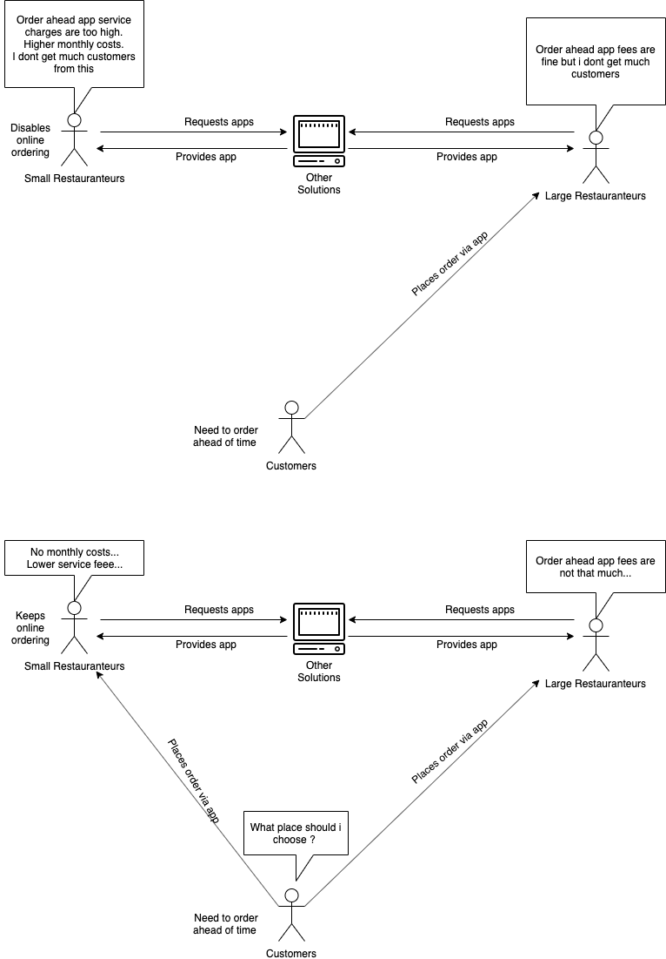

Figure 2: Rich Picture Diagram

# 3 Problem and Motivation

## 3.1 Problem

### 3.1.1 Background

Online ordering has been one of the most important factors when it comes to the restaurant and fast-food industry. With the emergence of the aggregate online ordering sites and application the restaurateurs have been forced to use one of them to get more income to their business.

According to a survey conducted by ToastTabs Guests have listed than online reservations and consumer ordering as restaurant technologies that are most important for their guest experience. Alternatively, restaurant professionals have list online ordering and gift card programs as some of the most important technologies for their business(Toast Inc., 2018)

51% of the online ordering have been done using the restaurants own website, while 38% of the orders have been placed using online aggregators like Doordash, Grubhub and Uber Eats, and 29% have been placed using an app for Restaurant or a food ordering service.(Toast Inc., 2018)

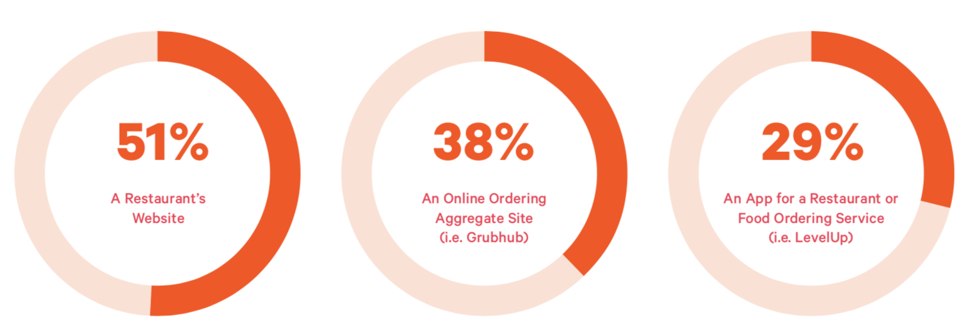

Figure 3 : ToastTabs survey on most used online ordering platform

As the amount of ordering using the restaurant websites have a 51% of customer usage the lack of a website will make the customers tend to find a different place to dine, so that they are able to enjoy their meals without waits.

### 3.1.2 General Problem

With the current available aggregate platforms, the restaurateurs have to pay a fee between 10% to 40% as a service fee per order, which reduces the income. The other mobile applications and websites generation platforms like Applova.inc charge a constant fee of $150(minimum) per month as a service charge disregarding the fact whether the restaurateurs have been able to get an increased sales revenue. With the service charges most of the current platforms puts the restaurateurs at a disadvantage, but the need of such an app makes the restaurateurs to stick with one of the existing platforms.

### 3.1.3 Research Question

How can blockchain can be useful eliminate monthly charges and the service fee per order?

With the use of blockchain, a decentralized way of storing data the service fee per order can be reduced to a greater extend or eliminated while allowing the monthly service charges to be eliminated, allowing the restaurateurs to have an increase in their income. Hyperledger fabric which is used in this solution will eliminate gas fees and other transaction costs that are been charged by other blockchain providers.

## 3.2 Aim

To allow restaurateurs to have their own online ordering website or mobile application with reduced or eliminated services fees per order and eliminated monthly service charges allowing them to increase their monthly revenue.

## 3.3 Motivation

To contribute for the success for small scale restaurants increasing their incomes, and to increase the use of blockchain. This is an attempt that is been made to achieve the target.

## 3.4 Objectives

1. To analyze how blockchain can be used to successfully provide a solution to reduce or eliminate service charges.
2. To implement a blockchain based solution to handle the problem.
3. To evaluate the fulfillment of the research objectives.

# Required Resources

## 4.1 Software Requirements

|  |  |
| --- | --- |
| IDE | InteliJ, Visual Studio Code, Webstorm |
| API | Node.js |
| Webstore | Spring MVC |
| Order Ahead Application | Spring MVC |
| Merchant Webb | Spring MVC |
| Blockchain | Hyperledger Fabric |
| Programming Languages | Java, TypeScript, JavaScript, Python |

Table 1 : Software Requirement for Development

## 4.2 Hardware Requirements

|  |  |
| --- | --- |
| Description | Minimum Requirements |
| Processor | 1.6GHZ or faster |
| RAM | 2GB or more |
| Browser | Chrome, Edge, Firefox |

Table 2: Hardware requirements from business

|  |  |
| --- | --- |
| Description | Minimum Requirements |
| Processor | 1.1GHZ or faster |
| RAM | 1GB or more |
| Browser | Chrome, Edge, Firefox |
| Wifi | Yes |

Table 3: Laptop and Mobile hardware requirements for customer

# 5. Project Requirement

## 5.1. Functional Requirements

1. The system must send emails once a user register.
2. The system must send email notifications to business once orders are received.
3. The system must send email notifications to user once the order is accepted.
4. The system should auto-generate webstore once the products are added.
5. The system should be able to run scripts and build the apk for user to download.

## 5.2 Non-Functional Requirements

1. The emails have to be sent with a latency of no longer than 3 minutes.
2. The processing and storing of data should be fast.
3. The webstore generation should be done immediately.
4. The apk generation should be done with a latency of no more than 1 day.

# 6. Timeline

Figure 4 : Timeline diagram

# References

1. Applova (no date) *No Title*.
2. HONG, L. W. (2016) ‘Food Ordering System Using Mobile Phone’, 147, pp. 11–40.
3. Kim, J. M. *et al.* (2019) ‘Proof of Phone: A Low-cost Blockchain Platform’, *2019 IEEE International Conference on Consumer Electronics, ICCE 2019*. IEEE, pp. 1–4. doi: 10.1109/ICCE.2019.8662107.
4. Magnani, A., Tilwani, J. and Suvarna, H. (2017) ‘Online Table Booking and Food Ordering System’, *IJSRD -International Journal for Scientific Research & Development|*, 5(01online), pp. 2321–613. Available at: http://www.ijsrd.com/articles/IJSRDV5I10561.pdf.
5. Toast Inc. (2018) ‘Restaurant Success in 2018’, pp. 1–27. Available at: https://pos.toasttab.com/hubfs/Content\_+\_Assets/2018 Restaurant Success Industry Report.pdf?hsCtaTracking=6c15aab7-e35d-4daa-a84b-a5303191078b%7C1339e588-3f3b-4dc4-8339-265c298c09ce